Submitted By

Sushma

961819106056

ECE

Ponjesly College Of Engineering

**DOOR BUZZER USING PIR SENSOR AND PUSH BUTTON**

**CODE**

#include<Servo.h>

Servo s;

void setup()

{

Serial.begin(9600);

pinMode(4,INPUT);

pinMode(12,OUTPUT);

pinMode(2,INPUT);

s.attach(8);

}

void loop()

{

int p=digitalRead(4);

Serial.println(p);

if(p!=0)

{

for(int i=0;i<1000;i=i+10)

{

tone(12,i);

delay(100);

noTone(12);

delay(100);

int a=digitalRead(2);

if(a==0)

{

for(i=0;i<=180;i++)

{

s.write(i);

delay(100);

}

for(int j=0;j<=30000;j++)

{

int b=digitalRead(2);

if(b==0)

{

for(int k=180;k>=0;k--)

{

s.write(k);

delay(100);

}

break;

}

}

break;

}

}

}

}

**TINKERCAD LINK**

<https://www.tinkercad.com/things/k1EjMJPDCBc-fantabulous-inari-blad/editel?sharecode=aa3JwhlMpPDe7NmSojjiTmvAhPbSNSFNmTgw2DYGmFY>

**Figure:**

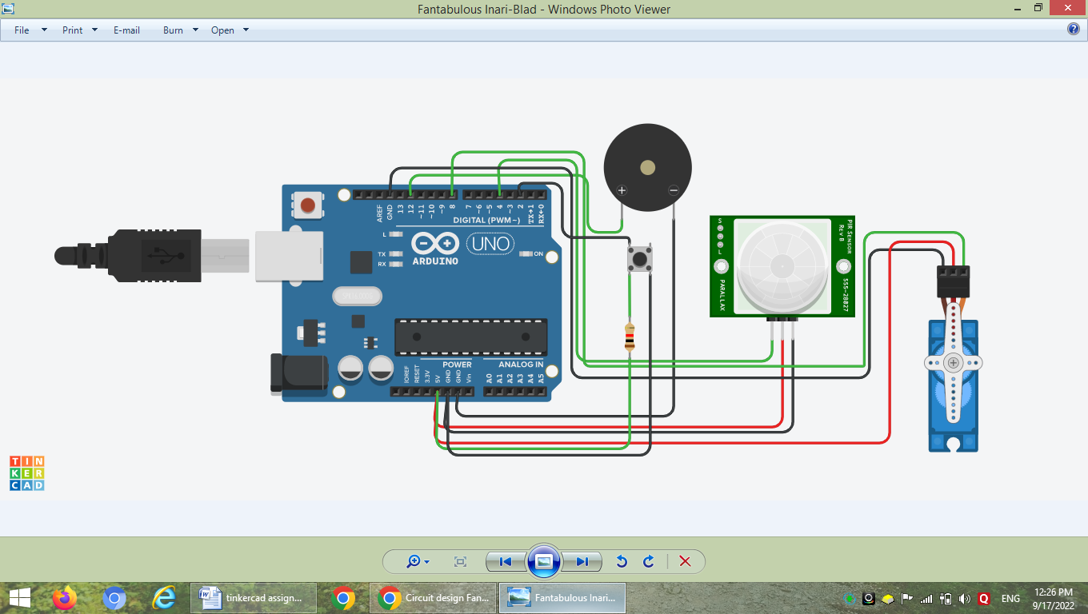

When someone comes in front of door ,the PIR sensor detect the motion of a person and the buzzer starts to ring. When the button is turned ON the buzzer stops and the stero motor starts to rotate and the door gets opened automatically. After a person comes into the home, the button would be pressed and the door get closed automatically again with the help of stero motor.